Pangilinan, Bien Gabrielle M.  
WD-301 | WCSERVER

server.js  
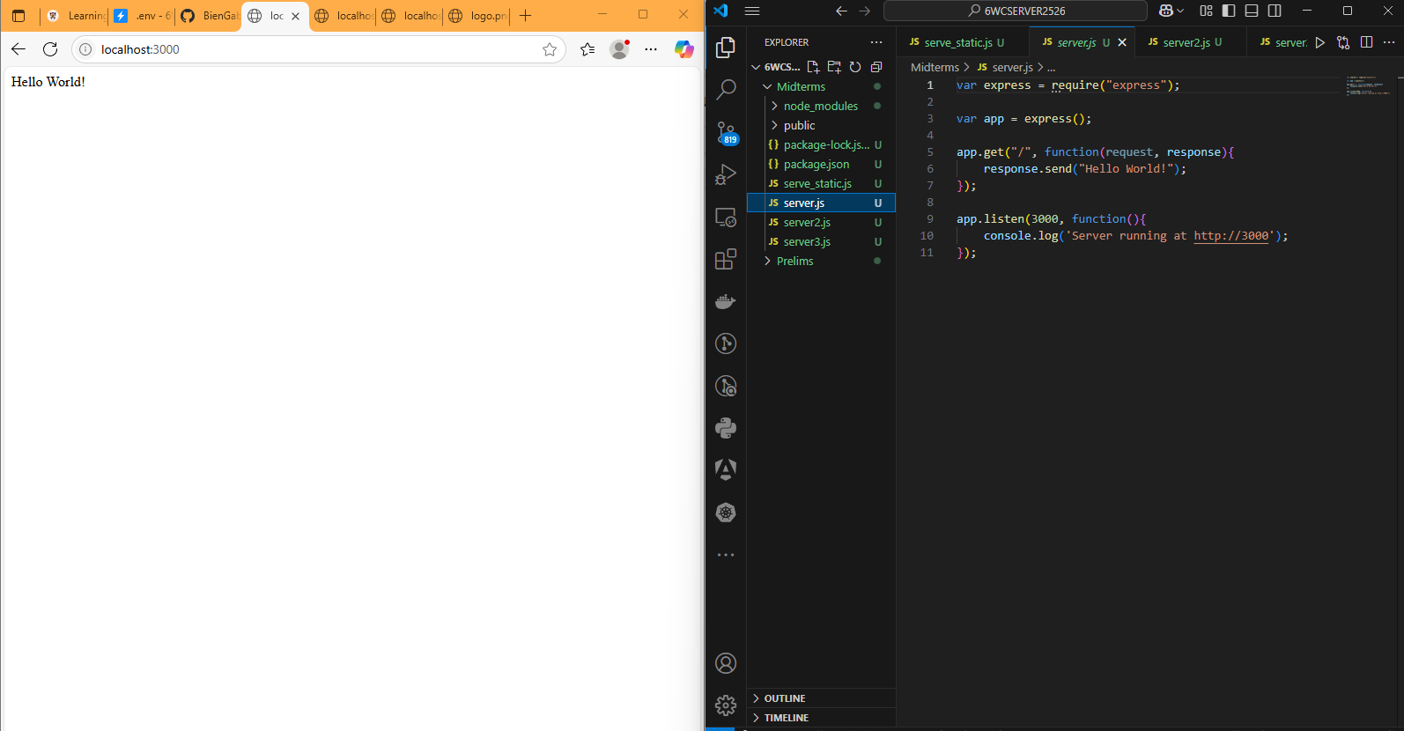  
server2.js  
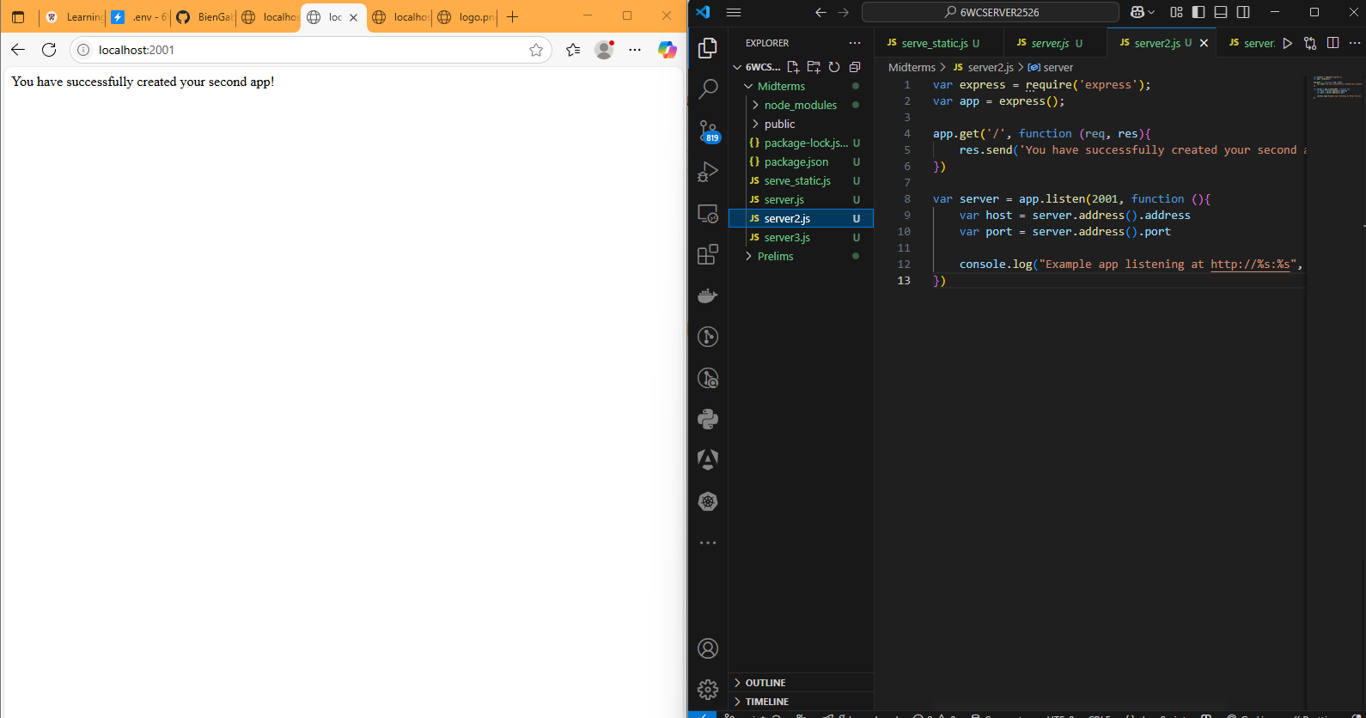  
server3.js  
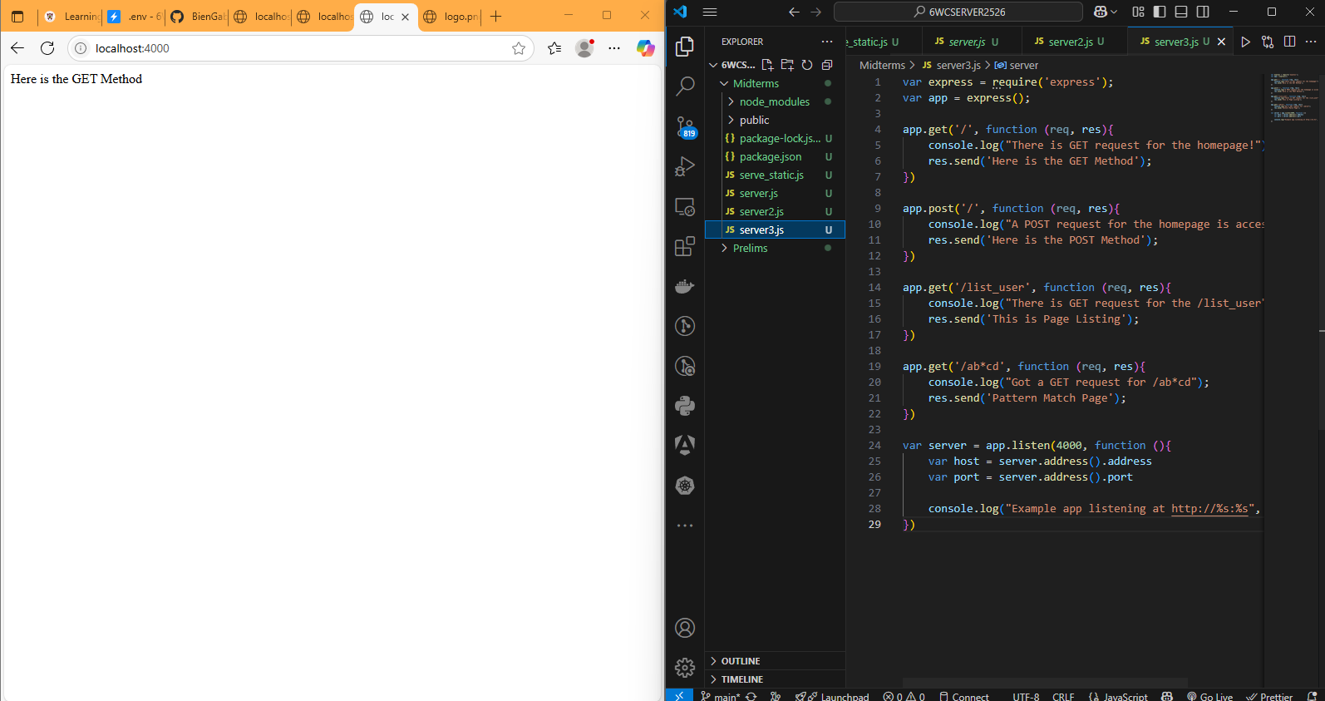  
serve_static.js  
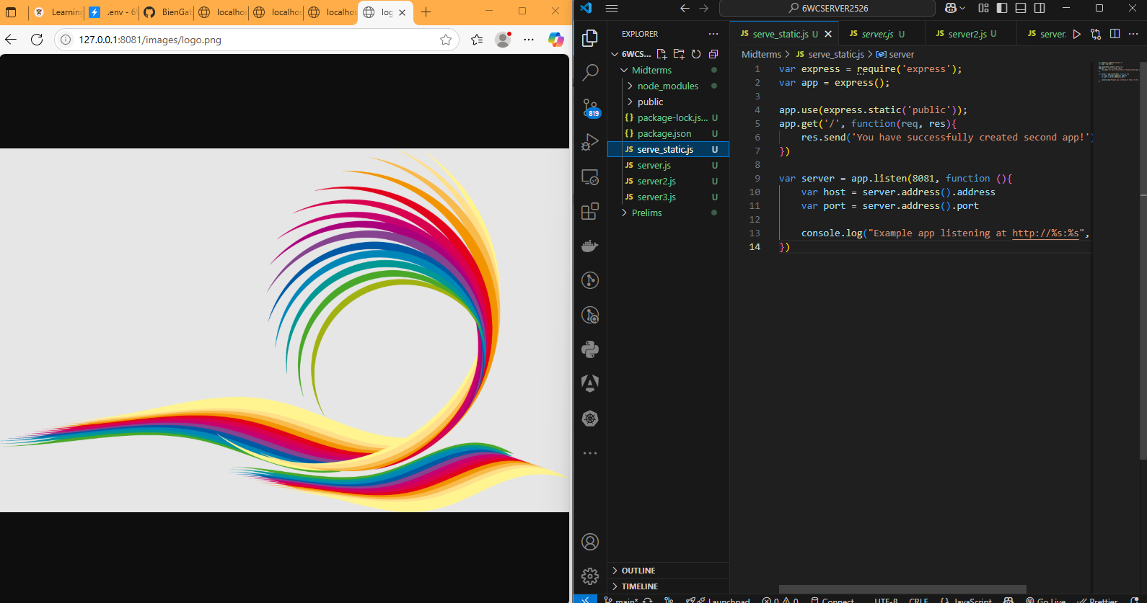  
  
Reflection:   
Learning ExpressJS was a simple way to get started with web server development. Setting up routes, managing requests, and providing static files were the fundamentals I mastered, and it gave me a better understanding of how the backend functions in actual projects.